CO₂’s Effects On the pH of Seawater at Various Temperatures

When rising CO₂ levels were first notably documented, many scientists and ecologists alike assumed that these gasses would be harmless to the environment and their effects, benign. Many researchers established collection stations, where CO₂ levels could be monitored and detailed data could be recorded. Annualized, the average data points collected by these stations rose every year. As scientists began to more carefully research the effects of rising CO₂ levels, they began to realize how horrifically inaccurate their assumptions had been. A comparative study between the data collected by these stations and the CO₂ bubbles captured in the ice-cores of the arctic, lead many to conclude that CO₂ today is about thirty percent more abundant than it was a few hundred years ago. Whether this extra thirty-percent may be as benign as critics claimed, remains to be seen.
Over forty-percent of the CO₂ released into the atmosphere remains in a gaseous form. The remaining sixty-percent, however, dissolves in the ocean and undergoes several chemical changes. Dissolved carbon-dioxide becomes carbonic acid (H₂CO₃), which dissociates its hydrogen ions and lowers the pH of the ocean water. Carbonic acid can then lead to an increased presence of bicarbonate ions (HCO₃⁻¹) and carbonate ions (CO₃⁻²), each with acidic properties that lower the pH themselves.
Changes to the ocean’s chemical properties greatly impact the survivability of the ocean’s life forms. Microbiological organisms such as phytoplankton feed off of CO₂; when there is an abundance of CO₂ in the water, these organisms ‘bloom’, or grow exponentially, to consume the CO₂ needed for the ocean’s plants. Once the primary producers are threatened, the primary consumers are threatened as well because their food supply is shrinking. This then threatens the meso-predators for the same reason. The same logic follows for all trophic levels ending with the apex predators like shark, whale, and tuna. Many of these predators are used as a food source for humans and when threatened, pose a direct threat to us. It is estimated that within one hundred years, the pH of the ocean will be so corrosive that it will corrode sea shells. Many life forms that depend on sea shells for structural integrity and protection will no longer be available to us nor, more importantly, will they be available to other marine organisms. The correlation between CO₂ levels and the population of primary-producers is inverse (up to an equilibrium point between the demand of CO₂ by life forms and the actual supply). Ergo, the relationship between our CO₂ emissions and our theoretical survivability (based on population growth estimates) is again negative.
In the following labs represent our exploration into the effects of CO2 emissions. The bubbles lab will explore how gaseous CO2, from our bodies, affects the pH of sea-water at various temperatures. Furthermore, the Shell lab will demonstrate the effects of pH and acidity on the structural integrity of sea shells.
Bubbles Lab
Pre-Lab Questions:

1. What gas are you blowing into the water?
Predominately, we are blowing Carbon-Dioxide into the water from our lungs. As we process the air we breathe, we create CO2 which is ultimately exhaled as a form of waste excretion.

2. What happens to the gas when you blow it into the water?
The carbon-dioxide we blow into the water is absorbed as Carbonic-Acid which dissociates it’s hydrogen ions and lowers the pH of the water, making it more acidic.

3. How are you measuring change in the water during this lab?
We are measuring the change in the water’s pH via “universal indicator”, which will react to the presence of CO2 by changing color.

4. What does measuring the pH of the water tell us?
By measuring the pH of the water, we can demonstrate how gaseous CO2 may upset the chemical balance of the water it makes contact with.

5. After studying the reactions above, how do you think carbonic acid will affect the pH of salt water?
I think that carbonic acid will dramatically lower the pH of the salt water through the releasing of hydrogen ions.
Hypothesis (es):
- If CO₂ is exhaled into the water, then the pH of the water will lower.
- If the water is warmer, then pH of the water will drop more dramatically (as compared to the other experimental and control groups)
Protocol:
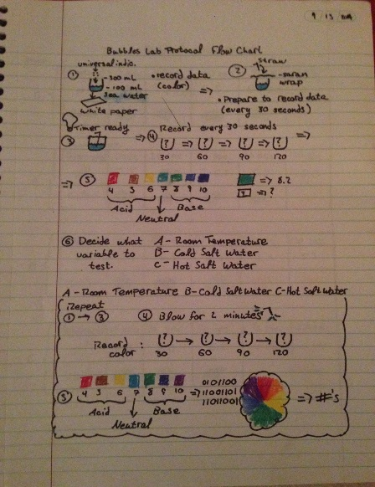
In the bubbles experiment, one control group and three experimental groups are employed. The control group will consist of sea water at room temperature. In this case, no variables are changed with regard to temperature and breathing time remains as the experimental constant. For the first experimental group (A), the pH of room temperature tap-water will be measured. The variable tested here is the change in pH of tap-water as compared to sea water. The remaining experimental groups (B & C) will test how varying temperatures affect the CO₂ absorption (and resulting pH) of sea water. For all groups, both control and experimental, the amount of CO₂ exposure is kept at a constant 2 minutes of exhalation. The independent variables in this experiment are the type of water (sea or tap) and temperature. The dependent variable in this experiment is the amount of CO₂ each group is exposed to (2min. of continuous exhaling).
Figure 1: Protocol Flow-Chart

Data Table:
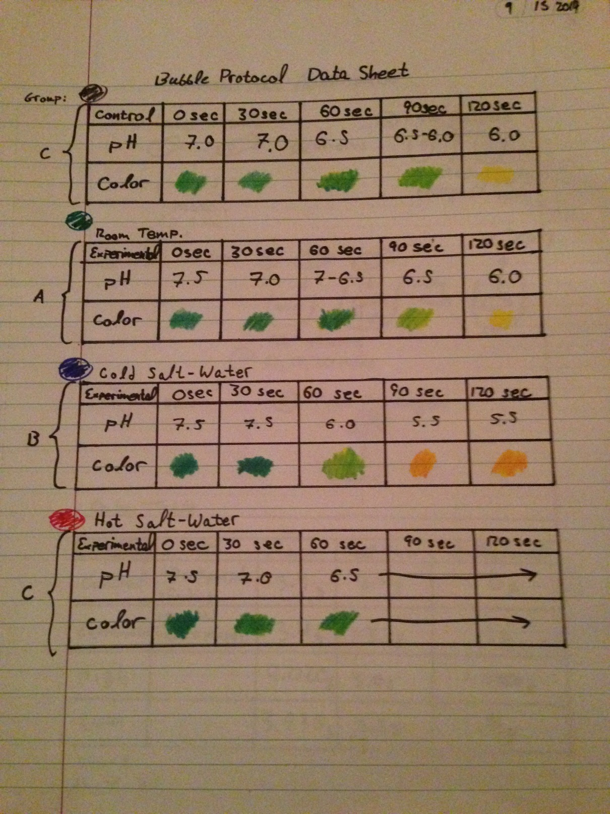
Figure 2: Data Table

Graph:
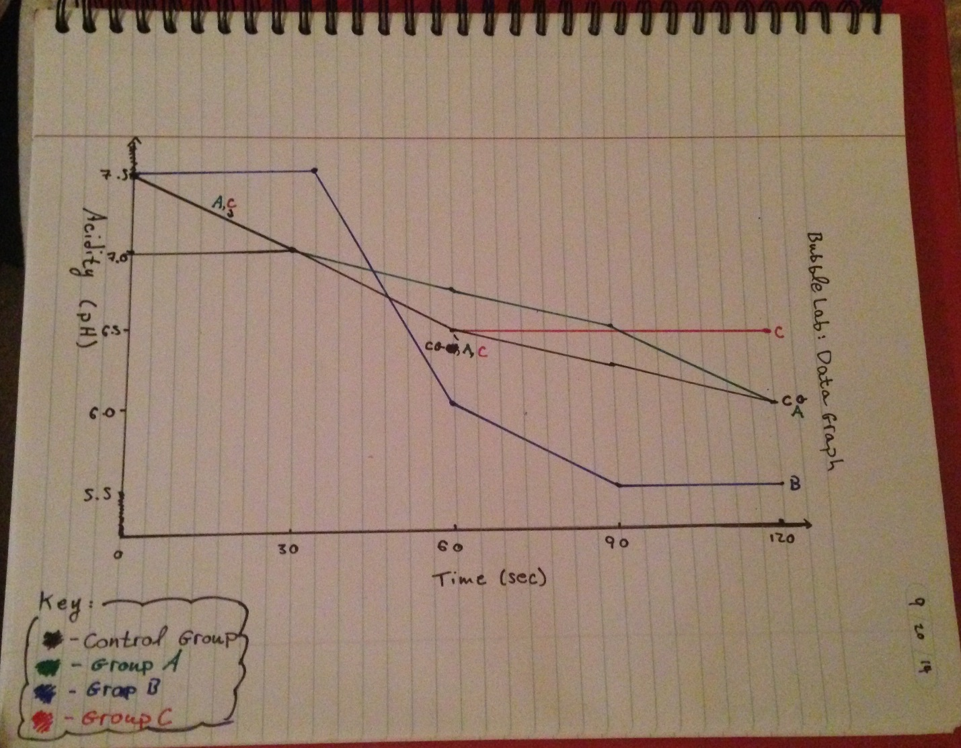
Figure 3: Graph
Data Analysis:
1. As you blew through the straw, what were you adding to the water and how did that change the pH?
As we exhaled into the water, we delivered gaseous CO2. When the CO2 dissolved, it formed carbonic acid and released hydrogen ions, lowering the pH of the water, making it more acidic.

2. What did the universal indicator tell us about the water?
The universal indicator told us the current pH of the water.

3. What does this tell us about the effects of carbonic acid in ocean water?
This tells us that carbonic acid lowers the pH of ocean water.

4. Based on the results of your experimental protocol, which factor affects the pH of the water most, temperature or salt?
According to our experimental protocol, temperature leads to greater pH effects from CO2 than salinity. As illustrated in experimental group B, colder water temperature leads to a more dramatic CO2 response.

Conclusion:
The data supports the conclusion that CO₂ emissions lead to lowered pHs in both salt and tap water. My second hypothesis, however, is not supported by the data. Experimental group B demonstrates that colder water responds more dramatically to CO2 emissions than warmer water, contrary to my expectations. I maintain that the colder water can suspend more CO2 between water molecules and thus holds more carbonic acid. I learned that as a body of water’s exposure to CO2 increases, the pH of the body of water decreases. This means that as CO2 increases, the ocean may be pushed to a pH range below the requirements of the inhabiting organisms.
Shell Lab
Pre-Lab Questions:
1. How do organisms make their shells? What are shells made of?
Organisms consume matter (Calcium & Carbon) to form Calcium Carbonate, the substance that forms shells.

2. What do you expect to happen to the shell in an acidic solution such as vinegar?
I expect the structural integrity of the shells to degrade when placed in a solution of vinegar.

3. What are sources of carbon dioxide and which of these sources are most likely to affect ocean pH?
Carbon dioxide is emitted through industrial processes, the burning of fossil fuels, and the leveling of rain forests (specifically the falling of trees). All gaseous CO2 emissions are likely to affect Ocean pH.

Hypothesis (es):
- If the exposure to vinegar increases, then the structural integrity of the shells decreases.
- If the exposure to vinegar increases, then the mass lost (difference between the pre-exposure and post-exposure masses) will be greater.
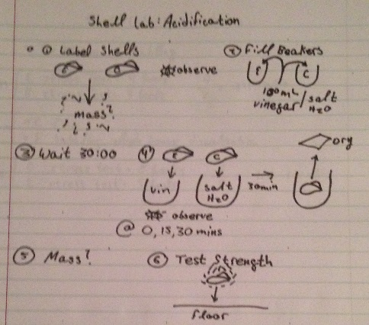
Protocol:
Figure 4: Flow Chart
The untreated shells are labeled either control or experimental (C or E). Their initial masses are then recorded using a scale. The control shell is placed a solution of salt water, the experimental is placed in vinegar, and the 30min timer begins. As these shells rest in their solutions, the pre-treated shells are stress tested using books. The shells that can support the larger number of books has a higher structural integrity relative to the others. The number of books supported per shell is recorded. After the timer has gone off, the shells masses are weighed, and they themselves are stress tested. The data is recorded and the lab is complete.
Data Analysis:
1. When you immersed the shells in vinegar how did you know that a reaction was happening?
We observed that a reaction what immediately occurring due to the bubbles that were released from the shell.

2. How did observing the shells in vinegar relate to how animals are affected by a lower pH of ocean water?
Phytoplankton, many of which rely on calcium-carbonate shells to survive, could not endure the acidity of a lower pH. Their shells would dissolve, or their membranes themselves. Furthermore, other small organisms would be killed by the caustic nature of the water and their inability to gather enough oxygen to breathe.

3. How would shelled organisms be affected by a lower pH of ocean water?
Many shell-using phytoplankton would not be able to survive in the lower pH ocean water due to the corrosion of their shells. They would become compromised by the acid and would cease to function.

4. What are the primary functions of shell for these animals?
Shells act as a form of protection from foreign organisms or from the water itself (much like plant cells use of cell walls).

5. Does it cost the animal energy to rebuild or repair their shell?
For an organism to rebuild or repair anything takes energy. As their shells were eaten away, many organisms would find that they were dedicating a lot of their energy into building it back.

Conclusion:
The data gathered throughout the lab serve to support my hypotheses. For example, the shells that were exposed to vinegar for large amounts of time supported fewer books than those that were. Furthermore, shells with higher vinegar exposures lost more net weight than those with lower exposures. I learned that as the pH of the ocean decreases, with it does the population of shell-dependent organisms, such as clam or phytoplankton. Ergo, as CO₂ emission increase, the phytoplankton population is likely to decrease.

