Temperature and Dissolved Oxygen Levels in Respiratory Solutions

In aquatic environments, the level of dissolved oxygen in the water is crucial to the development and survival of the ecosystem. Photosynthetic activity produces dissolved oxygen from dissolved carbon dioxide and contributes to the net productivity of the ecosystem. This process fights against respiration, the consumption of oxygen and carbohydrates for the production of energy (ATP) and carbon dioxide, which reduces the net productivity in the ecosystem. When the respiratory functions dominate the system, the system has a net loss of oxygen, and become unproductive. In this event, the life form may become starved for oxygen and their respective populations will decrease as a consequence of hypoxia and ultimately anoxia. This environment can arise as a result of eutrophication; a process in which algae build-up reduces the light saturation in lower areas of the ocean, killing the inhabiting plants, and ultimately cover the body’s floor with decomposing algae debris. Measuring dissolved oxygen in an environment becomes obviously quite significant. As temperature, dissolved carbon dioxide, and nutrient levels in an environment change. There are possible consequences for the levels of dissolved oxygen, and perhaps eventually the inhabiting life forms. Our study focuses on the effects of varying temperatures on the rate of respiration, as measured through dissolved oxygen.
Pre-lab Questions:
- List dissolved organic materials and possible sources that may decrease oxygen levels as a result of decomposition when present in water.
- Decaying organic matter – as bacteria feast of the decomposing flesh of dead animals, they consume the dissolved oxygen, reducing the carrying capacity of the water for other respiratory organisms.
- Algae – as algae blooms grow and over-populate, they prevent the sun-light from saturating the plants below, resulting in a reduced population of photosynthetic organisms living along the floor.
- List possible organisms that may act as decomposers of dissolved organic material in aquatic systems.
Bacteria feast upon the flesh of dead animals and organic matter. These organisms occur naturally in all decomposition systems and are crucial to the environment in the recycling of store nutrients from the bodies of dead things. If their populations bloom, however, they consume oxygen as a rapid rate and produce hypoxic and anoxic zones along the floor.
Experimental Questions:
How does the temperature of a system affect the rate of respiration?
This question can be measured the measurement of dissolved oxygen in the system, over time.
Hypothesis:
If the temperature increases, the rate of oxygen consumption will increase.
Protocol:
In our study, three groups will be employed (1 control, 2 experimental). All groups will contain:
- 40mL tap-water
- 10mL Methylene Blue (dilution, 30:1)
- 1tspn dried milk
Together, these ingredients will produce no change in the measure of dissolved oxygen content in the solutions. The control group (which employs only the above ingredients) will not respirate because no yeast is present. The experimental groups will contain 1tspn of yeast, which will respirate, consuming dissolved oxygen in the system. One experimental group will be left at room temperature and allowed to respirate, its dissolved oxygen levels will be recorded via photograph in 5 minute intervals. The second experimental group will be heated on a hot plate for 10 minutes, its dissolved oxygen levels will also be recorded at 5 minute intervals. After 10 minutes, the two experimental groups will be compared qualitatively and their data recorded as a final result.
Data Table:
 | 0 Minutes | 5 Minutes | 10 Minutes
Control
Room Temperature (E₁)
Hot (E₂)

Graph:
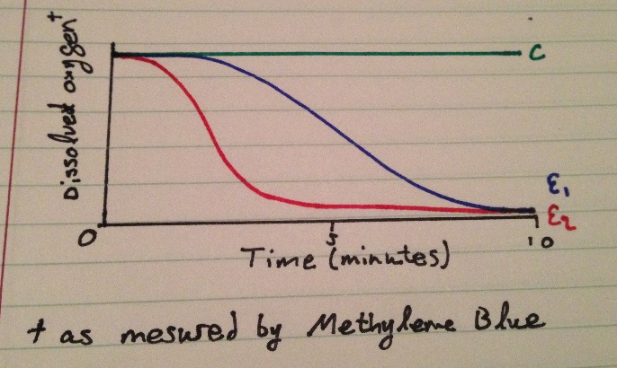
Dissolved Oxygen over Time.
Notes:
- Expressed conceptually, the % oxygen saturation cannot be determined with the data collected
- Dissolved oxygen measured by methylene-blue color change over time

Key
Control
Room Temperature (E₁)
Hot Temperature (E₂)

Conclusion:
The data gathered through our study confirms the hypothesis: if the temperature increases, the rate of oxygen consumption will increase. The control group illustrated no change, as respiration is impossible without an organism to respirate. The room temperature solution demonstrated constant and steady color change throughout the zero, five and ten minute intervals. As the milk was consumed by the yeast, the dissolved oxygen in the solution was steadily consumed as a result of respiration. The second experimental control group however, demonstrated rapid oxygen consumption over time, peaking at around the 2-3 minute level and stabilizing at near zero oxygen levels for the remaining time. This data allows for a conclusion of high-confidence to be achieved that temperature and the rate of oxygen consumption are positively correlated.

Appendix:
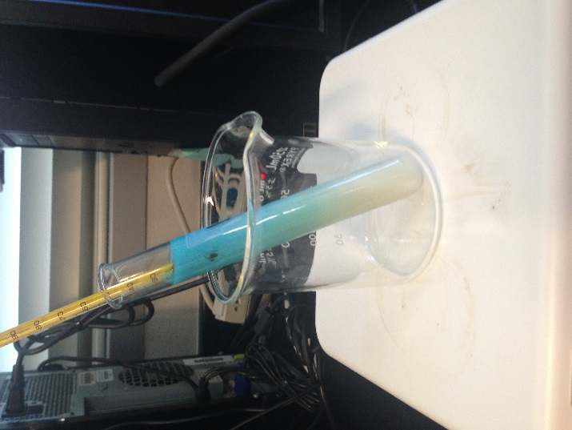
Figure 1: T-Zero
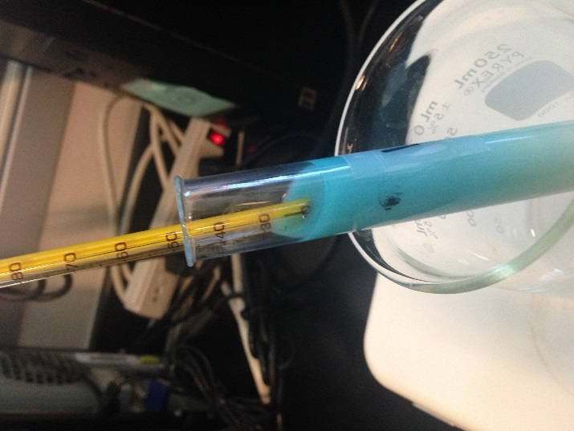
Figure 2: T-Zero Temperature
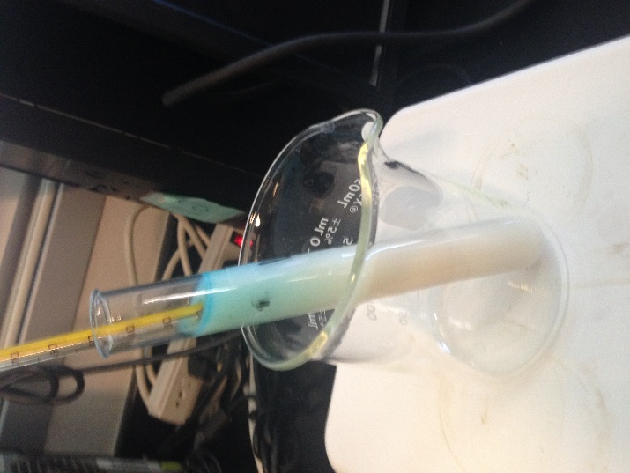
Figure 3: T-Five
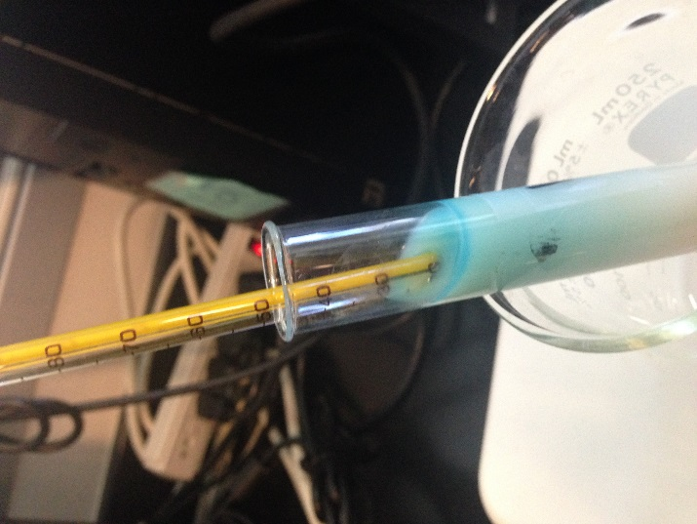
Figure 4: T-Five Temperature
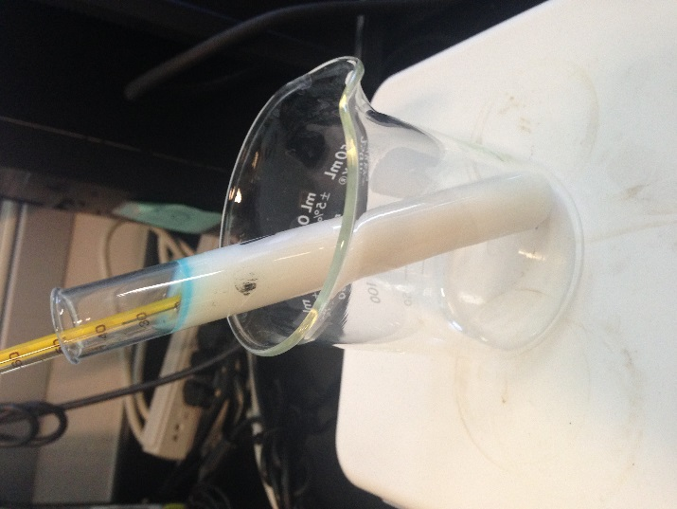
Figure 5: T-Ten

